

Project Document Cover Sheet

WALES Project Final Report

Project Information
Project Acronym | WALES
Project Title | Work-based Access to Learning through E-Services
Start Date | 1st April 2007 | End Date | 31st March 2009
Lead Institution | University of Glamorgan
Project Director | Jeremy Atkinson, Director, LCSS
Project Manager & contact details | Professor Tony Toole  Email: ttoole@glam.ac.uk  Address: University of Glamorgan  LCSS, Room J110  Pontypridd CF37 1DL  Tel: 01443 654092 Fax: 01443 482424
Partner Institutions | Coleg Sir Gâr, Swansea College, Merthyr College, Bridgend College, Coleg Glan-Hafren, Coleg Ystrad-Mynach
Project Web URL | http://wales.pbwiki.com
Programme Name (and number) | HE in FE (04/06)
Programme Manager | Lisa Gray

Document Name
Document Title | Final Report
Reporting Period
Author(s) & project role | Prof Tony Toole  Project Manager
Date | April 2009 | Filename | WALES Final Report
URL | http://wales.pbwiki.com/f/WALES+Final+Report.doc
Access | □ Project and JISC internal |  | √ General dissemination

Document History
Version | Date | Comments
1 | 21/01/09 | First draft
2 | 01/03/09 | Second draft
3 | 28/04/09 | Final draft

JISC Final Report

WALES

(Work-based Access to Learning through E-Services)

Author: Professor Tony Toole
Contact Details: University of Glamorgan
LCSS, Room J110
Pontypridd CF37 1DL
Tel: 01443 654092 Fax: 01443 482424

Date: April 2009

Table of Contents

Acknowledgements 4

Executive Summary 5

Background 6

Aims and Objectives 8

Methodology 8

Implementation 11

Outputs and Results 20

Outcomes and Impact 25

Conclusions and Recommendations 27

Implications for the Future 28

References 29

Acknowledgements

The WALES project was funded by JISC through the HE in FE theme of the e-Learning Capital Programme. The project team would like to thank Lisa Gray, the JISC Programme Manager for the support and guidance provided over the two years of the project.

The project was led by the University of Glamorgan through Learning and Corporate Support Services. Thanks are due to the staff of LCSS who provided administrative support for the project in a professional and friendly way.

The project partnership changed over the period of the project. In the final phase the main partners were Bridgend College, Merthyr College and Swansea College. The project team would like to thank colleagues in those institutions for their valuable contributions. Earlier in the project valuable contributions were also made by Coleg Sir Gâr, Coleg Glan-Hafren and Coleg Ystrad Mynach for which thanks are due.

Finally, the project team would like to express its gratitude for the support and advice provided by the JISC RSC Wales team during the project.

1. Executive Summary

The JISC funded WALES (Work based Access to Learning through E-Services) project investigated the potential of mobile technologies and social networking software to add value to the tutor/learner support mix for online work-based learners.
It used a Java based application developed at the University of Glamorgan to enable learners to interact with their virtual learning environment through their mobile phones. It also experimented with the use of social networking software to add functionality to the online support.
The programme was specifically aimed at evaluating the experience of learners undertaking HE courses supported by FE institutions.
The project first introduced the technologies to learners on a University of Glamorgan online Cert HE/Foundation Degree supported by tutors from FE partner Colleges. Later, the project introduced the same technologies to other HE courses delivered by FE partners including an MSc in Management, an HNC in Computing and NVQ4 Modules in Business Studies.
The MobiGlam application was downloaded to learner and tutor mobile phones and enabled them to access and interact with their Moodle VLEs. They would be alerted by SMS messages of information changes on Moodle and would be able to view Moodle information and respond from their mobiles without the need to be at a computer. The aim was to increase the flexibility and accessibility to learning support.
The use of social networking software was surveyed amongst learners with the objective of assessing the potential to exploit such software in supporting online learners. The use of Facebook and Delicious, in particular, was promoted.
The intention was to integrate the institutional technologies with the personal technologies used by the learners and with web based services in a way that added value to the learner experience. The use of the technologies was piloted with the courses in three FE colleges and the learner experience was evaluated.
The outcomes demonstrated that the use of mobile technology in the support mix was valued by the learners because of the immediacy it brought to the process by alerting them to events on Moodle and by significantly increasing the speed of responses to help requests.
The outcomes also showed, however, that there was a range of technical problems associated with institutional systems and the development of mobile technology that needed to be accommodated for the system to be sustainable.
The use of social networking software, where it was successfully integrated into the course delivery, was welcomed enthusiastically by the learners and was very effective, especially for group work.
However, for many work-based learners, their use and familiarity with social networking software was found to be very limited and the general applicability as part of online support is restricted at present.
The HE in FE issues that emerged as the project progressed related to the way in which academic teaching responsibilities and technical support systems were coordinated and managed. The FE sector does not have a research remit and systems are not geared to support active research projects of this kind. Project planning needs to recognise and accommodate this factor.
The overall message about mobile technologies and social networking software arising from the work of the WALES project is that the integration of user-owned technologies and web-based resources into the learner support mix is both feasible and desirable. The work points towards a future mixed economy of education where institutional, personal and internet based resources are combined in a way that optimises learner choice, learning effectiveness and economic value.

2. Background
2.1 Introduction
The aim of the WALES project was to explore the potential for mobile technologies and social networking software to enhance the experience of on-line learners. It sought to test and evaluate how such tools could be used to deliver a personalised learning experience to HE students supported by FE partner institutions. Specifically, it involved employees of SMEs across Wales undertaking the first year (Cert HE) of an on-line Foundation Degree; work-based learners taking individual NVQ4 modules; students completing year 2 of a Masters Degree and students following HNCs in Business and Computing.
The project was initially based on the work of an existing collaborative network of Higher and Further Education institutions called the Wales e-Training Network (WeTN). The Network, led by the University of Glamorgan, included a number of FE colleges who contributed modules to a Foundation Degree in e-Commerce and were providing tutor support for them during the first year of delivery.
A number of the same FE institutions were also supporting franchised HE awards validated by the University of Glamorgan and other validating bodies. After the first year of the project, the WeTN project came to an end and tutors and students from the other HE in FE courses participated during the second year of the project.
The HE in FE courses in involved in the project were:
Project | Course | FE Institution(s)
Year 1 | Cert HE in e-Commerce | Bridgend College, Swansea College, Coleg Glan-Hafren, Merthyr College
Year 2 | MSc Management Year 2 | Bridgend College
Year 2 | NVQ4 IT & Management | Swansea College
Year 2 | HNC End User Support Year 1 | Merthyr College

The project approach was the same for all the courses involved. Each course used Moodle as an online learning environment either as a distance learning support system or as part of a blended learning support system. The MobiGlam application, which enables users to use their mobile phones to interact with Moodle remotely, was provided for the tutors and learners to load on their mobile phones. They were invited to experiment with the use the communications it provided between Moodle and the mobiles in whatever way enhanced the communications and support for their course activities.
At the same time, the tutors and students were engaged in discussions about their use of social networking software and how it might also add value to their learning experience. Supported by the project, they were again invited to experiment with its use in the tutor/student communications mix.
2.2 The Wales e-Training Network
HE and FE institutions in Wales have been working collaboratively to create e-training solutions for SMEs since 2001. A highly successful network involving all the institutions in South West Wales was extended to include institutions across the whole country in 2004. The Wales e-Training Network (WeTN) developed a range of on-line modules at NVQ level 4 aimed at creating a work-based Foundation Degree in e-Commerce for Small Business Development.
The modules were completed and tested in 2006 and the first year of the Foundation Degree was prepared for validation by the University of Glamorgan as a Certificate of Higher Education. A pilot delivery of the programme began in April 2007.
The modules were being delivered fully on-line at a distance. The aim was to provide flexible and accessible training that allowed the learner to fit in their studies around their work and home commitments. The modules were being delivered using Moodle and the learners could access the course materials wherever and whenever they chose.
Central to learner support was the on-line tutor. The learning activities were based on materials provided on-line and the learners submitted the outcomes to the tutor for feedback and to share their experiences on Moodle forums moderated by the tutor. Email communications was also used extensively and learners had telephone access to a customer support service.
The rationale for the approach was based on the flexibility and accessibility it provided for the learner and the cost effectiveness and scalability it offered to the delivery institutions.
2.3 Mobile Technology and Social Networking Software
Mobile technology has become ubiquitous and there is increasing use of on-line social networking software, particularly amongst young people. The way in which the technologies are used is completely the choice of the individual and by using them regularly they are both skilled and comfortable with them.
The intention of the project was to explore the potential to use the same technologies to improve the way on-line learners, blended learners and campus based learners could be supported by tutors and other members of the award delivery teams.
The use of mobile phones means that all learners can send and receive communications, information and media files wherever and whenever they want. The portability and ‘always connected’ nature of the technology means that it can add significantly to the flexibility and convenience of engaging with aspects of on-line learning.
On-line learning itself provided anytime, anywhere, flexibility and learner control by allowing learners to participate from home or work using their personal computers. However even the need to have a physical connection to the Internet was becoming optional through the use of mobile technologies, broadening the choice and convenience of where and when to engage with learning.
There has been a rapid growth in the use of social networking software and social resource sharing in recent years. On-line content management and communications services that were largely the domain of corporate networks and, in education, virtual learning environment software applications, have become freely available through the development of Web 2.0 services and are being used in a social context.
On-line distance learning has been perceived as lacking in the social interaction provided by campus-based learning. The use of social networking applications such as Facebook and Secondlife are thought by many to have the potential to fundamentally change that perception and provide a much richer experience for the on-line learner.
As with mobile technology, the WALES project sought to investigate the potential use of social networking software as part of the learner support mix.
The importance of this work is that it is responding to changes in technology and the potential uses of technology to enhance education. It was felt that what we were possibly looking at the start of a new approach to learning using tools that allow the community of learners to take greater control of the processes, resources and communications services involved.
2.4 HE in FE
The project specifically addressed the needs of work-based and vocational learners. It was also an HE in FE project that examined the benefits and challenges in combining the practical, vocational, approach of the latter with the academic rigour of the former.
This report highlights a number of operational and cultural differences between the two sectors that need to be accounted for in the planning of cross-sectoral e-learning initiatives.

3. Aims and Objectives
3.1 The broad aim of the WALES project was to:
Implement and evaluate the use of mobile technologies and social software in the delivery of a personalised learning experience for work-based and vocational learners following HE blended learning programmes supported by FE institutions.
3.2 The project objectives were to:
- Design, implement and evaluate a tutor support system that included the use of mobile technologies; mobile phones, PDAs and other devices
- Include in the support system the use of social software such as Blogs, Wikis, instant messaging and discussion forums
- Experiment with the use of social on-line resource providers such as Google, Facebook, YouTube and del.icio.us
- Evaluate the effectiveness of the technologies in support of the administration of collaborative teaching and learning and access to support services
3.3 The evaluation framework questions being addressed were:
3.3.1 Achievement questions to be answered
- To what extent has our development work led to improved or more efficient practice in learning, teaching and administration?
- What technological developments have been achieved, and to what extent does their function, quality and supporting information make them suitable for uptake by the sector?
- What tangible/measurable benefits have been realised through the work of the programme?
3.3.1 Potential lessons to be learned:
- How can a range of technologies and approaches support learners in FE colleges in the development of HE-level skills?
- What are the issues around integrating student-and practitioner-owned technologies with institutional systems?
- How do learners experience and participate in learning in technology-rich environments?
- What are the drivers and brakes for successful implementation/use of technology?

4. Methodology
  - Overall Approach
The overall approach taken in the WALES project was to integrate the use of mobile technologies and social networking software into the online environment already being used by the students. The effectiveness of the additional functionality would then be evaluated in terms of the value and benefits it brought to the learning experience.
All of the learners involved were registered on University of Glamorgan HE qualifications being delivered by tutors at FE partner colleges. In each case the Moodle VLE was used to support delivery in either a blended or distance learning format. The mobile technology part of the project centred on the development and use of a Java based application that allowed communications between Moodle and the learners’ and tutors’ mobile phones. The social networking software part of the project involved an exploration of the learners’ social use of such software and experimentation in the way this could be integrated into their online learning environment.
The intention was to introduce the use of mobile technologies and social networking software as part of the tutor/learner support system in the most appropriate way for the curriculum area and institution involved. The approach taken, therefore, was to work through the tutors by providing them with the necessary skills and experience to use the technologies and allow them to apply that use with their learners in a way that was most beneficial.
The Java based application that allowed communications between Moodle and the learners’ and tutors’ mobile devices was developed at the University of Glamorgan by Fatma Elsayed Meawad and is called MobiGlam. The application was to be adapted for use by the implementations of Moodle being used by the FE partners, used as part of the delivery of their courses, and evaluated in terms of the contribution it made to their learning experience.
The use of social networking software in the tutor/learner support mix was to be based on the learners’ current use of such software in a social context, adapted to add benefit to the learning experience in parallel with the support provided through Moodle.
The evaluation methodology was based on individual interviews and semi-structured focus group meetings with tutors and learners.
  - Stakeholder Engagement
The project involved six University of Glamorgan FE partner colleges in the first year of the project and three in the second year. The original intention was to base all activities on the partner college support of Cert HE/Foundation Degree students through the Wales e-Training Network. The cessation of that programme after year one led to the involvement of four other HE courses in three of the FE colleges in year two. The broadening of the scope of the project in this way to involve other courses, though not originally planned, was seen to bring additional benefits by providing a correspondingly broader range of learner experiences.
The engagement with the FE partners was through the tutors who were leading the use of the new technologies with their student cohorts. This engagement included regular weekly online video conference team meetings, periodic face-to-face project meetings and planned workshops where training was provided on the use of the technologies. Records of these meetings are available on the project website.
The key stakeholders were the learners. They were primarily engaged in the project through interaction with their tutors. Project team intervention was through initial induction activities and concluding evaluation interviews and focus group meetings. The outcomes of these activities are presented in this report and form the basis for the conclusions drawn about the benefits of the use of the technologies in the support of online learners.
  - Technical Development
The mobile technologies to be used in the project were centred on the adaptation of the Java based MobiGlam application to allow the learners and tutors to communicate with Moodle through their mobile phones. This was to be carried out in the first year of the project and continue to be refined during year two. Two members of the project team were to be responsible for this aspect of the project. The MobiGlam application was developed by Fatma Elsayed Meawad in the Computer Based Teaching and Learning Research Unit at the University of Glamorgan, who was partly seconded to the project, and Paul Stokes who was responsible for the setting up and maintenance of the instances of Moodle used by the project.
The social networking software adoption was to be based on the current use of such software by the learners and also on an assessment of the educational benefits by the project team. The plan for the first year of the project was to survey the use of social networking software in this context generally, as well as gathering information from the learners about their personal usage and preferences. The second year would involve the introduction of chosen software applications into the tutor/learner support mix. James Durkan, with a background in instructional design and educational technology was to be responsible for this aspect.

  - Testing and Evaluation
In year one, the FE tutors involved in the delivery of the WeTN Cert HE, the programme leader at the University of Glamorgan and the customer support officer at Coleg Sir Gâr, were all to be involved in the use and evaluation of MobiGlam.
The project team had the task of supervising the installation of the MobiGlam application on their mobile phones and coaching them in the use of the functionality and planning the introduction to their student cohorts.
In the second year of the project the process was repeated with the new tutors and plans for the introduction of social networking software usage were included. Following two periods of trialling, evaluation of the learner and tutor experiences was to be carried out through interviews with the tutors and semi-structured focus group meetings with the learners.
The key feature of the methodology was the decision to allow the tutors and the learners to take full control of the process. Once the new technologies were in place and the tutors and learners were familiar with their functionality, it would be a matter for them to decide how best to exploit the technologies in the tutor/learner support mix.
  - Project Management
The project lead institution was the University of Glamorgan in partnership with Merthyr College, Bridgend College, Swansea College, Coleg Sir Gâr, Coleg Glan-Hafren and Coleg Ystrad-Mynach. All were represented on the project steering/working group that met periodically.
The project team was based at the University of Glamorgan and comprised:
Project Director: Dr Ron Cobley, Head of ISeLS (year 1). Jeremy Atkinson, Director of LCSS (year 2)
Project Manager: Professor Tony Toole
Educational Technologist Fatma Elsayed Meawad
(mobile technology)
Educational Technologist James Durkan
(social networking software)
Web Programmer Paul Stokes
The project team met weekly along with the FE partner college tutors using the Open University Flashmeeting online video conference system. A regular participant was also RSC Wales. All online meetings were recorded and these are available on the project website.
  - Dissemination
The dissemination plan for the project had three main elements:
- A project website where all project documents would be made available including work in progress, reports, research outputs and project deliverables.
- Conference and seminar presentations: regular presentations were to be made throughout the project at regional, national and international events.
- A project report that would synthesise and summarise the project outcomes and deliverables, document the lessons learned and draw conclusions about the implications for the future of technology enhanced learning.

5. Implementation
5.1 Summary
The WALES project started in April 2007 and concluded in March 2009. It began with an initial setup period where the MobiGlam application was set up to work with the Wales e-Training Network (WeTN) Moodle. The original plan was to base all of the project activity on the online Cert HE/FD in e-Commerce developed by WeTN and for this purpose all the FE partner college tutors, along with the programme leader based at the University of Glamorgan, had MobiGlam set up and tested on their mobile phones. The tutors and the project team then introduced the learners to MobiGlam and an initial trial of usage took place in the autumn of 2007.
At the same time, a survey of social networking software (SNS) by the learners (and tutors) was carried out. The expectation of widespread usage was not confirmed by the survey. The learners were all mature working adults and the actual usage of SNS was found to be very low. It was decided, therefore, to begin the SNS part of the project with a research exercise to identify the global use of SNS in an educational context and then to implement a more proactive introduction into the tutor/learner mix based on the results.
The outcomes of the first MobiGlam trial were reviewed in December 2007 and the clear message was that both the students and the learners benefited from the flexibility and immediacy of the support it provided. There were, however, a number of technical problems relating to the different phones and service providers involved that needed to be solved by the project team for the next phase of piloting.
In the Spring of 2008, the first of a number of institutional issues impacted on the project and caused a change of plan. Following the end of the WeTN initiative in March 2008, the decision was taken by the University of Glamorgan not to continue delivering the online Cert HE/FD in e-Commerce. Other HE courses supported by the FE partners were examined and proposals to include courses at HNC, NVQ4 and MSc level at three of the partners were included in a revised project plan.
Arrangements were made for two pilot delivery periods with the new courses during the second half of 2008 and early 2009. Institutional challenges that were addressed in the lead-up to these pilots included the need to liaise with different technical support teams in each of the FE partner colleges, the loss of one of the key tutors through promotion to another job and a similar loss of the Educational Technologist responsible for MobiGlam as a result of taking up a post in Egypt.
Solutions and work-arounds were found for these problems, but the effect was to delay the pilot periods and mean that testing and evaluation continued to the end of the project period in March 2009.
5.2 Mobile Technology
Most attempts to build mobile learning environments have adopted server side solutions that use internet browsers on the mobile devices to access VLEs,. This has been reported to provide limited usability because of the small screen size and the fact that only certain mobile phones and PDAs have the required functionality.
The MobiGlam solution mixes client side and server side approaches in a design that allows all mobile devices to retrieve content from a VLE and customise it according to the mobile device capability. MobiGlam does not attempt to present static learning content, concentrating more on dynamic content and activities such as news, grades, events, assignments, workshops and forums.
It recognises the fact that almost all mobile devices come with a pre-installed Java virtual machine which means that a lightweight Java application could provide a user-friendly interface while keeping the communication process compact and efficient.
The following diagram shows the basic MobiGlam infrastructure:
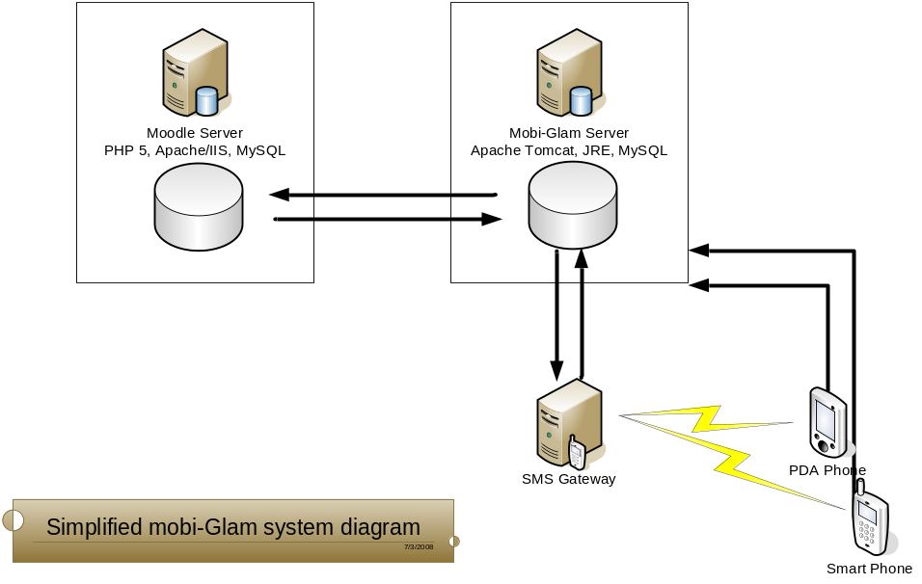
The key design features are:
- The use of a J2ME mobile client instead of a built in mobile browser (if it has one);
- The use of Web services to establish a communications channel between the client and server side;
- Generating granular representations of learning content on the server side to suit the requirements of wireless technologies;
- The use of an SMS gateway to alert users when significant information is changed on the VLE
In order to use MobiGlam the learners and the tutors needed to be registered users on their Moodle server and to have downloaded the Java application (MIDlet) to their mobile phone or PDA. The download is initiated on the MobiGlam website:
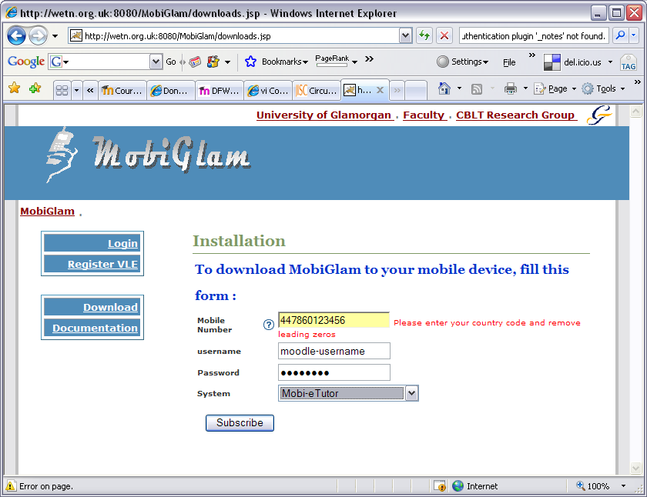
A text message is sent to the mobile phone with a link included which, when clicked, starts the download and installation of the MIDlet.
When installed the user can activate the MIDlet on their phones and will be invited to login:
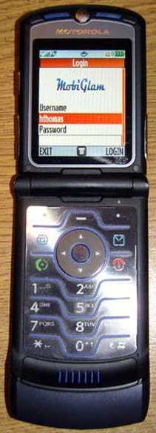
Once logged in the user will see their Moodle courses:
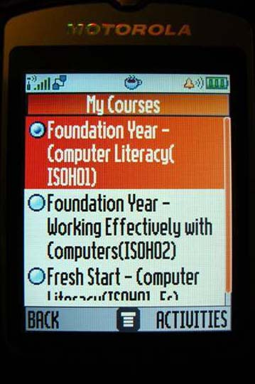
And by clicking on a particular course will see the range of Moodle activities they can access from their phone:
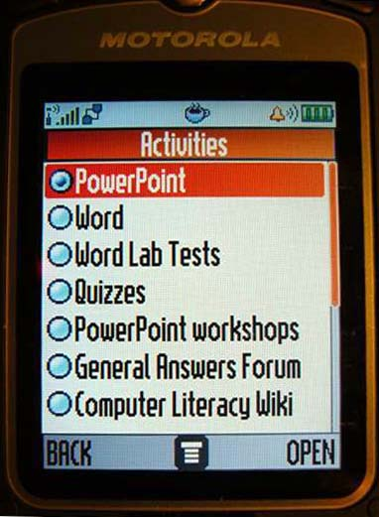

5.3 Moodle
Moodle is the current VLE of choice in the FE sector in Wales, it is also used in the HE sector although most institutions, including the University of Glamorgan, have installed Blackboard/ WebCT as the institutional VLE.
The first phase in this project involved the WeTN Cert HE/FD in e-Commerce delivered through a Moodle installation hosted through the University of Glamorgan. It was therefore a single installation and very straightforward to link to MobiGlam.
In the second phase of the project the three FE institutions involved each had their own Moodle installation and wanted to experiment with the use of MobiGlam. This involved the project team liaising with the IT support staff at each college and raised issues that were difficult to resolve.
The main problem was that there was no resource provision for partner college technical support in the project budget. This meant that, with the best will in the world, it was difficult to guarantee actions when they were needed from staff who were not part of the project.
After a period of frustrating delays in the summer of 2008 it was decided to set up mirror Moodle servers managed by the project team at Glamorgan for each of the partner colleges. Not ideal as the learners and tutors were then working with more than one VLE, but a necessary pragmatic solution.
5.4 Social Networking Software
The original intention with this part of the project was to survey learners on their use of social networking software and to explore how such usage could be exploited as part of the tutor/learner support mix.
The survey was carried out in phase 1 of the project when the learners were recruited to the Cert HE/FD online course. All were work-based learners and all were visited in the workplace when they joined the course. The survey was carried out as a semi-structured interview and revealed that this grouping of mature adult learners made very little use of SNS.
Most (but not all) had heard of YouTube, Facebook, Skype and similar relatively high profile services, but a typical response was: “Oh that’s what my son does, I don’t”. When questioned about Secondlife, Delicious and Twitter their knowledge, let alone experience, was practically zero.
Their actual Web usage was more conventional in that they used it for information, often using Google, and used email a lot. A number of small business owners had websites and some traded online, though the sites were normally commercially produced.
The decision was taken at this time to abandon the original plan and undertake a research exercise to scope the current usage of social networking software, both generally and in an educational context.
In the second phase of the project where the new courses involved had learners with a younger age profile, there was a significantly higher usage of Facebook, YouTube and Bebo in particular, but still only 50-60% of each group. Based on the research exercise it was decided to introduce two specific SNS services and integrate them into the Moodle delivery, these being course Facebook groups and social bookmarking using Delicious.
5.5 Institution and Project Partner Issues
There were two types of institutional issue that arose from the project and needed to be dealt with. The first related to the relatively long timescale of the project which meant that individual and institutional circumstances were likely to change during that period and would need to be dealt with. These included:
- A key member of the project team left early in the second phase;
- One tutor left early in the second phase as a result of getting a new post at a different institution and two other tutors were made redundant at around the same time;
- The original course upon which the project was based came up for re-validation and was not supported for continuation.
The second institutional issue related to the different operating circumstances of FE institutions compared with HE:
- In FE the teaching responsibilities of tutors are not necessarily finalised until the beginning of the new teaching year. This means that although the intention is for individuals to participate in the project, they may not actually be in a position to;
- In FE, IT support services may be de-centralised, overstretched, and not able to participate in project support. Although IT support can be built into the project team, access to institutional IT systems is unlikely to be allowed.
Such issues need to be thought through and planned for. Robust and realistic mitigating actions need to be built into the original project risk analysis and re-visited at key points during the project delivery.
5.6 Trials and Evaluation
There were three trial delivery and evaluation periods during the WALES project. The initial setup and trial of MobiGlam with the Cert HE/FD tutors and learners took place in Autumn 2007, the trial with the tutors and learners of the HNC, NVQ4 and MSc courses began in Autumn 2008 and continued in Spring 2009.
5.6.1 Trial period 1
The initial setup and trial was mainly for the project team and tutors to become familiar with MobiGlam and to experiment with its functionality. A small number of learners also joined in the trial. A number of technical glitches were identified and fixed by the project team. An evaluation meeting was held in December 2007 where the trial outcomes were discussed.
Details:
Course: Cert HE e-Commerce |  | Validated by: University of Glamorgan
FE Partners | Bridgend College | Swansea College | Coleg Glan-Hafren
Modules | Introduction to the Internet an e-Business | System Security & e-Commerce | Networking Concepts
Attendance | Distance learning
Tutors | Matt Smith | Owen Phillips | Maura Capone
Learners | 8 | 3 | 5

During this delivery period (October 2007 – December 2007) all the module tutors, HE and FE, downloaded and tested the MobiGlam application. Just 3 learners also downloaded and tested the application at this time.
5.6.2 Trial period 2
The second trial period in 2008 involved a number of new tutors and again there were technical glitches to resolve. It became apparent at this time that the new emerging generation of phones were not allowing the MIDlet download and issues with Blackberry and iPhones remain problematic.
Meetings were held at each of the institutions with the learners who were to become involved in the project to outline the use and potential benefits of MobiGlam and to survey the learners’ use of social networking software. At each meeting it was explained that it would be a matter for the tutors and the learners in each cohort to decide how best to exploit the use of MobiGlam and social networking software to benefit the learning process.
Details:
Course: MSc Management | Validated by: University of Glamorgan
FE Partner | Bridgend College
Tutor | Matt Smith
Attendance pattern | Part-time, one day per week
Learners | 9

Course: HNC End User Support | Validated by: University of Glamorgan
FE Partner | Merthyr College
Tutor | Chris Bissex/Christine Rees
Attendance pattern | Part-time, evening only
Learners | 7

A total of 10 learners downloaded and tested the application during this period.
The fourth course joined the project towards the end of the second period:
Details:
Course: NVQ4 Management | Validated by: ILM/City & Guilds
FE Partner | Swansea College
Tutor | Owen Phillips
Attendance pattern | Part-time, one day per fortnight
Learners | 20

Two groups of work-based NVQ learners were involved in this trial and were introduced to the project and arrangements made for the download of MobiGlam for trials in the third trial period in early 2009.
5.6.3 Trial period 3
The third trial in 2009 was more successful with 4 tutors and 25 learners participating. By this time the groups had discussed between them the way in which they were going to use MobiGlam and social networking software in the trials and were implementing it.
In Bridgend, the tutor set up discussion forums on Moodle for each of the topics and assessments in the MSc course for that period. All postings made on those forums would cause SMS alerts to be sent to everyone’s mobile phones and they could respond accordingly. The plan was to evaluate how effective this was in stimulating discussion and assisting in the learning process.

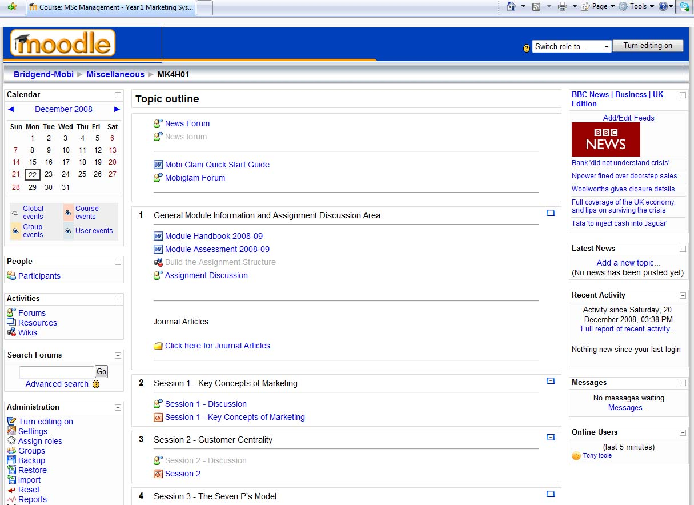

The Bridgend group decided not to include social networking software in the mix as only half of the group used such things as Facebook regularly and there was some resistance to its use in a work context.
In Merthyr, the plan was to use Moodle, MobiGlam and Facebook in an integrated way to assist in the course group-work needed to complete their learning activities and assignments. The learners only met face-to-face two evenings per week and it was felt that online tools like this could add significantly to that process.
With this group, all but one student were enthusiastic Facebook users and even that student did have a Facebook account and was not averse to using it for group communications. Perhaps crucially, one of the tutors was also an enthusiastic Facebook user and the other was an expert user and keen advocate of Moodle for blended learning delivery.
There was significant use of the Moodle forums and Facebook for the group work. The students initiated many of the discussions as indicated in the screenshot below, and took control of the process.
It was particularly interesting to note the social negotiating that took place between the students about their participation in the course:
- One particular group felt a member was not pulling their weight and they risked group failure as a result. A member of the group diplomatically brought that student back as a contributor through subtle online messaging;
- One member of the cohort did not attend evening sessions for two weeks running. The group discussed this between themselves and then communicated with the missing student. Through encouragement they persuaded her to resume her participation.
All this was in full knowledge of the tutor but without her intervening. It emphasised the social component of the cohort experience and the value of the social networking tools in facilitating the communications.

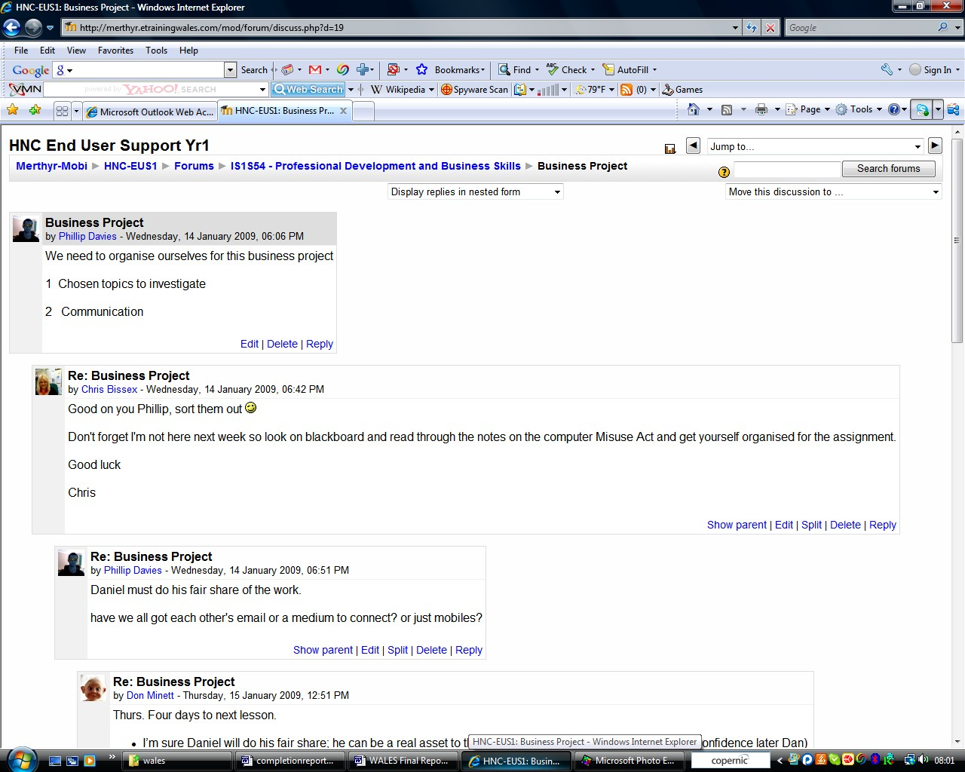

The cohort of NVQ work-based learners at Swansea College were NHS professionals with an average age of 45yrs. They attended face-to-face sessions once every 2 weeks and did not have the same level of social contact as the Merthyr group.
The Swansea cohort had less usage of social networking software than even the Bridgend students and they decided also not to include this in their pilot activities; preferring to experiment with Moodle and the use of MobiGlam.
Towards the end of the pilot period the experience of the learners and tutors for each of the pilot cohorts was evaluated through focus group meetings and the outcomes recorded. Their views on the benefits of MobiGlam and the value of using social software in support of the learning process were discussed.
5.7 Dissemination
The dissemination plan was implemented with the website being set up early in the project at http://wales.pbwiki.com and a schedule of conference and seminar presentations planned. The conference presentations were made at regional, national and international levels during the project period. Regular participation in programme meetings, e-learning expert group meetings and other JISC events allowed dissemination of the project activities within the JISC community.
The final project dissemination event was held in Cardiff on 3rd April 2009 as a joint event with the JISC eTutor and ReCITE projects. The event was fully subscribed and included a keynote presentation by Professor Andy Lane, Director of OpenLearn at the OU, as well as some valuable group discussions about the issues raised. Details of the dissemination activities, including the final project dissemination event in Cardiff and downloadable versions of all the presentations and reports, including this one, are available from the dissemination page on the project website.

6. Outputs and Results

6.1 Summary
The WALES project developed the MobiGlam application to allow learner and tutor communications with the Moodle VLE and their mobile phones. The application was piloted and evaluated with four different HE courses supported by FE partner colleges.
At the same time, research was carried out into the use of social networking software in an educational context and a survey was carried out of the current social use of such software by the learners involved in the MobiGlam piloting. The learners and tutors were provided with guidance and were encouraged to include social networking software in the tutor/learner support mix.
The main deliverable from the project was this final report which includes the outcomes of the evaluation exercises and the lessons learned about the use of mobile technology and social networking software in the support of HE work-based learners. The key outcomes of the evaluation activities are presented below.
Other deliverables include the MobiGlam application, which is available for use by the JISC community, together with system information and a user guide. The MobiGlam application may be viewed at: http://www.wetn.org.uk:8080/MobiGlam/ and the user guide is downloadable from the project website deliverables page: http://wales.pbwiki.com/Project+Deliverables.
A series of research reports on social networking software and its use in an educational context were produced, along with tutor and learner guides on the use of social bookmarking and these are also downloadable from the deliverables page. A series of project reports are available at: http://wales.pbwiki.com/Project+Reports and the dissemination presentations are available at: http://wales.pbwiki.com/Dissemination.
6.2 Evaluation
The evaluation of the learner experience in the use of MobiGlam and Social Networking Software was carried out through focus group meetings with learners and tutors at each of the three FE colleges involved in the pilot exercises. The evaluation reports are available on the project website at: http://wales.pbwiki.com/Project-Partners.
The evaluation covered the following areas of learner experience:

General Information
- Number in group
- Number downloaded MobiGlam
- Number succeeded in installing the client
- Number using Moodle
- Number using SNS

Use of Moodle
- Moodle functionality used (forums, modules etc)
- Frequency of using Moodle
- Way Moodle integrated with course delivery
- General comments about using Moodle
- General comments about online learning

Use of Mobi-Glam
- Frequency of use of MobiGlam
- Functionality of MobiGlam used (SMS, activities, forum posts etc)
- Ease of Use of MobiGlam
- Problems with using MobiGlam
- Way MobiGlam worked with different phones (survey phones & service providers)
- Benefits of using MobiGlam
- Negative experiences with MobiGlam
- Suggestions for improvement (functionality, message management, menu structure, ease of use, screen presentation etc)
- Views on the future use of mobile technology in education

Use of Social Networking
- Types of SNS used (Facebook, Twitter, YouTube etc)
- Frequency of using SNS
- Personal motivation for using SNS
- Use of SNS as part of course
- Views on using SNS to improve learner experience (group comms, tutor comms, access to resources etc)
- Negative aspects of using SNS
- Suggestions for improvement
- Views on the future of SNS in education
6.3 Results
The results from the evaluation exercises varied considerably between institutions and courses for a variety of reasons that will be examined. The key to the success of both the mobile technology and social networking software in enhancing the learner experience was the tangible benefit they brought to that learning experience.
6.31 Merthyr College
The students at Merthyr College used Moodle, MobiGlam and Facebook in an integrated way that produced significant added value and was largely learner led (although with subtle tutor encouragement). The forum postings, text messages and the face-to-face focus group evaluation meeting all confirmed the benefits that the learners believed the technologies brought to their learning experience.
The following sample of Moodle forum/MobiGlam messages illustrates the activity where learners were acting as a self-help group, both for their group work and problems with the technology:
Postings:

My phone is rubbish by [Learner 1] - Thursday, 29 January 2009, 09:57 PM
Hi all. Don’t know if your getting my messages as the posts are not coming through to my phone,I only know if someones posted something if I log into mobiglam and have a look. I also posted a message last week and uploaded some stuff and got no reply, so I don’t know if you're even getting my posts.
ps- I'll e-mail those slides to you [Learner 2] sometime tomorrow and also a Big Thanks to [Learner 3] for all he's done this week. Bye

Re: My phone is rubbish by [Learner 3] - Friday, 30 January 2009, 03:52 PM
Hi [Learner 1] Well it looks like your messages are getting to me ok babe....... No idea about the rest of them. I'm sure they'll let you know though. I should have replied yesterday when I got the text,,, to be honest, I couldn't stop [Learner 4] talking on FB so didn't have time.
ps, why don't these smilies work??

Business Project by [Learner 3] - Thursday, 15 January 2009, 12:51 PM
Thursday:. Four days to next lesson.
- I’m sure [Learner 5] will do his fair share; he can be a real asset to this project. ( I'll have the fiver for that vote of confidence later)
- Congratulations on passing your Theory test [Learner 5]. Get the practical done know and you can start giving us a lift home...lol.
- I think we need to get some kind of schedule for meeting to do the group project.... Preferably in a bar but hay I'm easy.
- Happy studying, see you all soon.
Re: Business Project by [Learner 1] - Thursday, 17 January 2009, 02:35 PM
Hi everyone. Would it be okay if I do the introduction? I know some of us are having a hard time finding the time but do not forget we are a team and I'm here if you need me to do anything for you.

On-line Workshop by [Learner 2] - Wednesday, 4 February 2009, 05:01 PM
Anyone feel like going over some stuff on-line tonight... Be on Facebook about 6am... Could have a look at lectures that we should have had Monday and today. If any thoughts on them why not share them???

Re: On-line workshop by[Learner 5] - Wednesday, 4 February 2009, 05:05 PM
Ok that is fine by me. Talk then.

The evaluation outcomes for this group were:
General information:
The five learners participating in the evaluation were using 3 different makes of mobile phone through 4 different service providers. All had downloaded MobiGlam without any problems and all had used Moodle and received the SMS messages. All used social networking software, particularly Facebook.
Use of Moodle:
The group used Moodle regularly to access resources, participate in forums and to post messages and upload work. They mostly used it from home and valued the communications for group-work, particularly over the half-term break.
Use of MobiGlam:
The frequency of use of MobiGlam was aligned to that of Moodle. The learners remarked specifically on the immediacy of the information it provided through the SMS messages relating to activity on Moodle and the ability to respond using their phones. It was seen as something that added significant value to the use of Moodle.
Having said that, when questioned about how intrusive the SMS messages were, it was felt there should be some restrictions on use in ‘leisure time’. In fact the group agreed that postings to Moodle forums would not be made after 9pm so that messages would not be received by everybody after that time.
A discussion about how MobiGlam could be improved led to the suggestion of having a personal scheduler that limited messages to certain times and to queue messages received outside those times. The learners reported that there was ‘a lot of messing around at the start’ before getting used to the functionality with their particular phones and recommended, quite reasonably, that there should be better client install arrangements and a resolution of the firewall issue.
Use of Social Networking Software:
All the group but one used Facebook a lot and reported always having it in a window on the screen when using their computers at home. One also used Bebo and another Delicious. All used instant messaging. The key benefit was that it provided instant communications – no complicated navigation.
Their view on the use of social networking software in learning was completely positive: ‘well, it’s how we communicate’. Evidence from the postings and messages showed that much of the communications was learner-led and that it would have happened anyway if the project had not taken place. It was clear that the cohort had gelled as a social group and this motivated the communications.
Although very small, this group demonstrated how value could be brought to the learning experience by the use of personal technologies and social software.
6.32 Bridgend College
By contrast, the students at Bridgend College did not engage with the technology to any great extent despite encouragement by the tutor. This was as a result of the learners experiencing difficulty downloading the MobiGlam application due to firewall issues at the institution. There was also a lack of perceived value and consequently no learner dynamic to drive the process as there was in the previous example.
Clearly there is a problem with the use of such technologies if the institutional network blocks the necessary communications and has policies that restrict access to social networking sites from college computers. The three learners who did install the MobiGlam client on this course did so from home.
The tutor tried very hard to stimulate discussion on Moodle and created forums for all topics and assignments and regularly posted encouraging messages. However, there was limited response and the reason appeared to be that the use of Moodle was peripheral to the face-to-face course delivery.
The group evaluation outcomes were:
General information:
Only 3 out of the 9 learners downloaded MobiGlam. The others had firewall problems at the college, one had a mobile that was too old, one had a service provider that blocked MobiGlam and another chose not to participate (a self-confessed technophobe). The use of Moodle was restricted to accessing coursework and occasional participation in the forum discussions. There was no use of SNS as part of the pilot. The exercise was compromised by the tutor leaving the college at the start of the exercise and supporting the students whilst starting a new post at a different institution.
Use of Moodle:
The tutor attempted to use Moodle as part of the delivery mix for what was a conventional part-time campus based course. Although the students used it to access course materials and assignments, the added value it brought to their learning experience was not evident to them and their participation in the forums was minimal.
Use of MobiGlam:
Because of the technical problems and the minimal use of Moodle, the trial was not successful. Although there were technical issues, the main reason why the group didn’t persevere in solving the problems and using the application was the perceived lack of value added it offered to their learning experience.
Use of Social Networking Software
Only 5 out of the 9 learners used social networking. Those that did primarily used Facebook and MySpace, though only two did so on a daily basis. The age of the learners varied between this course to those in the previous example where they were younger and this appeared to have an impact on their motivation to use social networking software. Some of those who were using such software socially were not comfortable with its use in a ‘work context’.
From the tone of the previous example, where there was acceptance of the use of social networking software in an educational context, there was also a strong social element in the dialogue and this may be the key to an effective online group dynamic.
6.33 Swansea College
The students at Swansea College had the oldest average age of the three cohorts and their confidence with new technology and use of social networking software was the lowest. The way they used computers generally and the consequent engagement with forums on Moodle directly impacted on both the effectiveness of MobiGlam and the contribution of social networking to their learning experience.
The group evaluation outcomes were:
General information:
5 out of the 20 students downloaded MobiGlam. Technical problems were reported installing the application on the mobile phones were reported by the others that appeared to be largely due to restrictions by service providers. Students using one provider had no problems, regardless of the phone manufacturer; others using another provider always had problems.
The cohort only attended face-to-face once per fortnight and most reported only using Moodle when they attended those sessions. Their use of computers at home for social reasons was only 15%, the rest being at work or for their NVQ course.
Use of Moodle:
The group made good use of Moodle for accessing their learning materials but did not use the forums or wikis. Their engagement was mostly in class with only limited use from home. This was reported to be between 1 and 3 visits per week. Their general response to online learning was that it was beneficial in the way it provided access to learning materials, but that it took time away from their main focus which was to complete their work based NVQ commitments.
Use of MobiGlam:
The use of MobiGlam was restricted to the receiving of SMS messages and the exchange of text messages with the tutor. The value for learning was diminished because the students were not using Moodle extensively and hence the MobiGlam functionality was not being exploited.
As with the Bridgend students, the technical difficulties associated (particularly) with service providers making download difficult, contributed to the lack of use. An interesting observation was that the MobiGlam screen presentation had ‘an old feel to it’ compared with other applications on the phone.
Use of Social Networking Software
Only two of the learners reported using SNS regularly (Facebook and YouTube). However there was a general agreement that it could have significant benefits for learning, though as an add-on rather than a core activity. A number of students highlighted the fact that social networking was discouraged in the workplace (as it is in some institutions).
There was no use of SNS in the NVQ delivery apart from that led by the tutor in the face-to-face sessions.

7. Outcomes and Impact

The WALES project sought to explore the benefits brought to the online tutor/learner support system by the use of mobile technologies and social networking software. It did this in the context of work-based learners being supported by FE institutions delivering HE qualifications.
The outcomes, impact and lessons learned will be presented here in terms of mobile technologies, social networking, work-based learning, HE in FE and other programme level objectives.
7.1 Mobile Technologies
The key project objective here was to: Design, implement and evaluate a tutor support system that included the use of mobile technologies; mobile phones, PDAs and other devices.
The MobiGlam system was designed to maximise the benefit of using mobile phones in the learner support mix by linking directly with the online learning environment and providing communications and content management services optimised for the mobile devices.
The key design feature of MobiGlam was that it took information from Moodle and restructured it for display on the small mobile phone screens, rather than just use the phone as a browser to access Moodle. In this way it uses mobiles for what they are good at: information interchange and communications.
There were installation and mobile phone related issues to be addressed, but overall the system worked very well technically when the MobiGlam client was successfully installed. The full range of functionality was tested successfully and the SMS server also functioned as planned.
Although the piloting was not as extensive as we would have liked, mainly because of the technical and operational problems, the evaluation was sufficient to confirm that, in the one implementation where Moodle was central to the learning activity, both learners and tutors felt MobiGlam added significantly to the support system.
However, in the other two implementations where Moodle was not central to the learning activity the potential benefits of MobiGlam were not realised.
Also, a key lesson learned that needs to be acted on is that mobile technologies are developing at a rapid rate and that the MobiGlam system needs to be developed in parallel, and in negotiation with service providers, to remain both compatible and optimised.
7.2 Social Networking
The key project objective here was to: Experiment with the use of social on-line service providers such as Google, Facebook, YouTube and delicious in the learning support system.
As with the mobile technology, where the use of social networking software was successfully integrated into the learning process it was seen to be of great value, especially for part-time and distance learning students who used it for effective group work. Facebook was particularly favoured as a collaboration tool.
It was felt that some specific social networking functionality would be particularly beneficial in a learning context, social bookmarking being a good example, and systems integrated with Moodle were successfully set up and tested. However, the delays in piloting for the reasons explained in this report, meant that a full evaluation was not possible in the timescale.
The key message that came from the social networking software pilot was that networking requires a group dynamic to be successful and that this in turn arises from two key motivators: a demonstrable contribution to the learning process and the creation of a social aspect to networking interaction.
The lesson learned was that social networking software has significant potential in an educational context and that usage, although not widespread enough yet with adult learners to use it consistently for learner support, is likely to become an important component in the future.
An indication from the work of this project is that social networking might provide the solution to the problem, often associated with online distance learning, of social isolation.
7.3 Work-based Learning
The WALES project was focussed on HE courses delivered to work-based learners and was designed to assess the benefits that new technologies could bring to these types of learners.
The flexibility and ‘always on’ nature of mobile technology, coupled with the direct link to their learning environment was reported as the big plus for work-based learners. Effective group work would be virtually impossible were it not for the Moodle forums being used and the SMS alerts notifying group members of new postings were seen as a big benefit. Facebook was seen as a benefit because of the rapid interaction it stimulated. Learners reported that they kept Facebook open in a window when they were working on group assignments at home.
The lesson learned was that work-based learners have to fit their learning around their work and home commitments and that anything that aids in that process is valued. A particular benefit with the mobile technology was the speed of response from tutors to queries who tended to respond from their mobiles wherever and whenever the messages were received.
However, the project identified the fact that work-based learners are mature adults who do not use emerging technologies as readily as younger learners and this creates barriers to their use in the learner support mix. It is anticipated that this will change in time but they are always likely to lag behind the early adopters of future technologies. This factor needs to be accounted for in the use of new technologies.
7.4 HE in FE
A key programme level objective was to assess how the technologies addressed the specific issues relating to the delivery of HE courses by FE institutions.
There were specific issues relating to the differences in academic delivery planning and in the technical support systems that emerged during the project. There was a high level of commitment on the part of the FE academic staff to the innovative way of supporting learners being piloted by the project. However their workloads and particular academic management constraints make project work difficult to integrate. A similar constraint emerged regarding IT support staff.
Academic responsibilities for FE staff are much more varied and flexible than in HE. Individual members of staff have their schedule for the year set out by departmental management and may have quite different responsibilities from one academic year to the next. The FE academic’s workload, in terms of teaching hours, is much greater than in HE as it is generally a teaching only role with no research component. This variation plus the greater hours means a significant amount of time spent on teaching planning and preparation.
The net effect of the difference in academic responsibilities between HE and FE staff means that FE staff have less time available for learners outside timetabled sessions. However, in practice, FE staff have a well deserved reputation for being accessible to learners and often operate and ‘open door’ policy for learners whenever on campus.
From a project point of view, the uncertainty about teaching responsibilities has impact if tutors participating early in the project change later in the project. This may not only be disruptive, but can also have significant resource and time implications if, for example, staff training for participation is involved.
The lesson learned was that, when working collaboratively between HE and FE institutions it is important to fully understand the different operational constraints and cultures when planning innovative developments. It is also important to build this knowledge into the project planning so that resources are allocated appropriately and that management at all levels has the goals of the project as part of their responsibility.
7.5 Evaluation Framework Questions
- To what extent has our development work led to improved or more efficient practice in learning, teaching and administration?
The project has demonstrated that mobile technology and social networking software can be effectively linked to the online learning environment to add significant flexibility and accessibility for the learner and the tutor. There are, however, ongoing technical issues to resolve and learner preferences to accommodate before those benefits can be generally realised.
- What technological developments have been achieved, and to what extent does their function, quality and supporting information make them suitable for uptake by the sector?
The project has tested a particular implementation of mobile technology that has been shown to provide a new level of functionality. The technology will need to develop as mobile and learning environment technologies development, but the principle and practice is available for uptake by the sector. Similarly, the project has demonstrated that, when embraced by the learners, social networking software can also add significantly to the learning experience.
- What tangible/measurable benefits have been realised through the work of the programme?
The benefits are evidenced by the learner and tutor feedback from the evaluation. The objective was to assess the benefits of mobile technologies and social networking software and although there were problems and issues to be addressed, the potential of both was demonstrated by the project.
Lessons Learned:
- How can a range of technologies and approaches support learners in FE colleges in the development of HE-level skills?
This project is one of a number that have illustrated how technology can contribute to the more vocationally aligned HE studies that are supported by FE institutions. Particularly when the studies are work-based, the accessibility and flexibility offered by online and mobile technologies can add greatly to the learning experience.
- What are the issues around integrating student-and practitioner-owned technologies with institutional systems?
The WALES project addressed this issue directly. The MobiGlam server/client side framework was designed specifically to map the information in the institutional Moodle environment to the learner-owned mobile phone/PDA environment. The issue is understanding both systems and being able to map between the two.
- How do learners experience and participate in learning in technology-rich environments?
This project demonstrated that, for the cohorts involved, learners have yet to fully embrace technology rich environments and the same is true for institutions. There can be no doubt that future learner-owned and institutional technologies will combine to radically change the way learners participate, but for the moment we are still early on in that journey.
- What are the drivers and brakes for successful implementation/use of technology?
The key driver for any implementation of technology is to clearly demonstrate added value. The main brake is to fail to do so.

8. Conclusions & Recommendations

It can be concluded from the work of the WALES project that mobile technology, in particular, can significantly add benefit to the learning experience when added to the tutor/learner support mix. The design and implementation of the MobiGlam system successfully allows mobile devices to communicate with, and receive information from, institutional online learning environments and in doing so, adds flexibility and accessibility to the learning experience.
It is recommended that the JISC community considers further developments using this approach and it is hoped that other practitioners will consider adopting and adapting MobiGlam to refine and improve the functionality. The WALES project team would certainly be pleased to collaborate with other groups in continuing the development.
It can be implied from the outcomes of the research into social networking software and its educational applications that future learning environments are likely to exploit the developing affordances and functionality of such applications. An expectation is that there will be a fully global movement towards the sharing of educational resources and that this will largely be through Web 2.0 services rather than individual institutional servers.
It is recommended that the JISC community continues to support research and development in the use of social networking software. It should accept the fact that such software is at a relatively early stage of development, but that it is likely to become a defining feature in future online learning environments.
It can be concluded that the support of HE by FE institutions can benefit from the introduction of technology, but only if both educational systems are understood by all stakeholders and their particular operational systems are party to and integrated with the systems being introduced.
It is recommended that continued collaboration be encouraged between the HE and FE sectors to exploit their complementary strengths of academic rigour and ground breaking research on the one hand, with practical applicability and industrial relevance on the other. This project and others have demonstrated how the innovative application of technology can assist in this.

9. Implications for the future

The use of mobile technologies and social networking software will continue to develop and evolve in parallel with computing technology and the affordances of the internet generally. It will have a transformative effect on the delivery of education in the same way it will transform other aspects of society.
The WALES project team believes that the approach it has taken will inform the debate about the future use of such technologies and that the MobiGlam system could be usefully taken forward as part of a personalised learning environment.
MobiGlam is available for use and adaptation by the JISC community and is already used by Athabasca University with over 37,000 online students. All of the FE partners in the project have expressed an interest in using the system after the project funding finishes and the project is likely to result in continued usage across the partner network.
The use of social networking software is increasing as it becomes more robust, user friendly and feature rich. There are already projects that are exploring the possibility that Web 2.0 services and social networking software applications will be used to create personalised learning environments in the future.
It cannot be ignored, however, that there were significant technical barriers to overcome when integrating personal, institutional and internet based technologies. The experience and preferences of different types of learners has also been shown to impact on the use of new technologies. All this needs to be factored in to future planning.
The overall message arising from the work of the WALES project is that the integration of user-owned technologies and web-based resources into the learner support mix is both feasible and desirable. The work points towards a future mixed economy of education where institutional, personal and internet based resources are combined in a way that optimises learner choice, learning effectiveness and economic value.

References
Links to references are included in the text or as footnotes. Full references are presented here.

- Wales eTraining Network Website 2007. [accessed 1st March 2009]. <www.etrainingwales.com>
- JISC Events: Innovative Learning with Mobile and Wireless Technology 2008. [accessed 1st March 2009]. <http://www.jisc.ac.uk/events/2008/05/mobileandwireless.aspx>
- JISC InfoNet: Social Software InfoKit 2008. [accessed 1st March 2009]. <http://www.jiscinfonet.ac.uk/infokits/social-software>
- Elsayed Meawad & Stubbs 2007. A framework for interoperability with vles for large scale deployment of mobile learning. In The 4th International Workshop on Wireless, Mobile and Ubiquitous Technologies in Education, WMUTE, Athens, Greece, November 2006. IEEE, Computer Society. [accessed 1st March 2009]. <http://computing.research.glam.ac.uk/media/files/documents/2006-11-26/Microsoft_Word_-_26els.pdf>
- JISC WALES project website management meeting archive 2009. [accessed 1st March 2009]. <http://wales.pbwiki.com/Management+Meeting+Archive>
- Goh & Kinshuk 2004. Getting ready for mobile learning. In World Conference on Educational Multimedia, Hypermedia and Telecommunications. Vol 1. pp56-63.
- Laakko & Hiltunen 2005. Adapting Web content to mobile user agents. Internet Computing, IEEE Vol 9, Issue 2. pp46-53.
- JISC Innovative Practice with e-Learning 2005. [accessed 1st March 2009]. <http://www.jisc.ac.uk/media/documents/publications/innovativepe.pdf>
- JISC WALES project website Dissemination page 2009. [accessed 1st March 2009]. http://wales.pbwiki.com/Dissemination
- JISC WALES project website Deliverables page 2009. [accessed 1st March 2009]. http://wales.pbwiki.com/Project+Deliverables
- JISC WALES project website Project Reports page 2009. [accessed 1st March 2009]. http://wales.pbwiki.com/Project+Reports
- Athabasca University Mobile Moodle Project 2009, [accessed 1st March 2009]. http://cde.athabascau.ca/umlautm/
- JISC eTutor Project website 2009. [accessed 1st March 2009]. http://etutor.pbwiki.com

www.etrainingwales.com
http://www.jisc.ac.uk/events/2008/05/mobileandwireless.aspx
http://www.jiscinfonet.ac.uk/infokits/social-software
http://computing.research.glam.ac.uk/media/files/documents/2006-11-26/Microsoft_Word_-_26els.pdf
http://wales.pbwiki.com/Management+Meeting+Archive
http://wales.pbwiki.com/Management+Meeting+Archive
Goh & Kinshuk (2004) Getting ready for mobile learning. In World Conference on Educational Multimedia, Hypermedia and Telecommunications. Vol 1. pp56-63.
Laakko & Hiltunen (2005) Adapting Web content to mobile user agents. Internet Computing, IEEE Vol 9, Issue 2. pp46-53.
http://www.jisc.ac.uk/media/documents/publications/innovativepe.pdf
http://wales.pbwiki.com/Dissemination
http://cde.athabascau.ca/umlautm/
http://etutor.pbwiki.com

